**Github SetUp:**

1. **Go to below URL**

**https://github.com/**

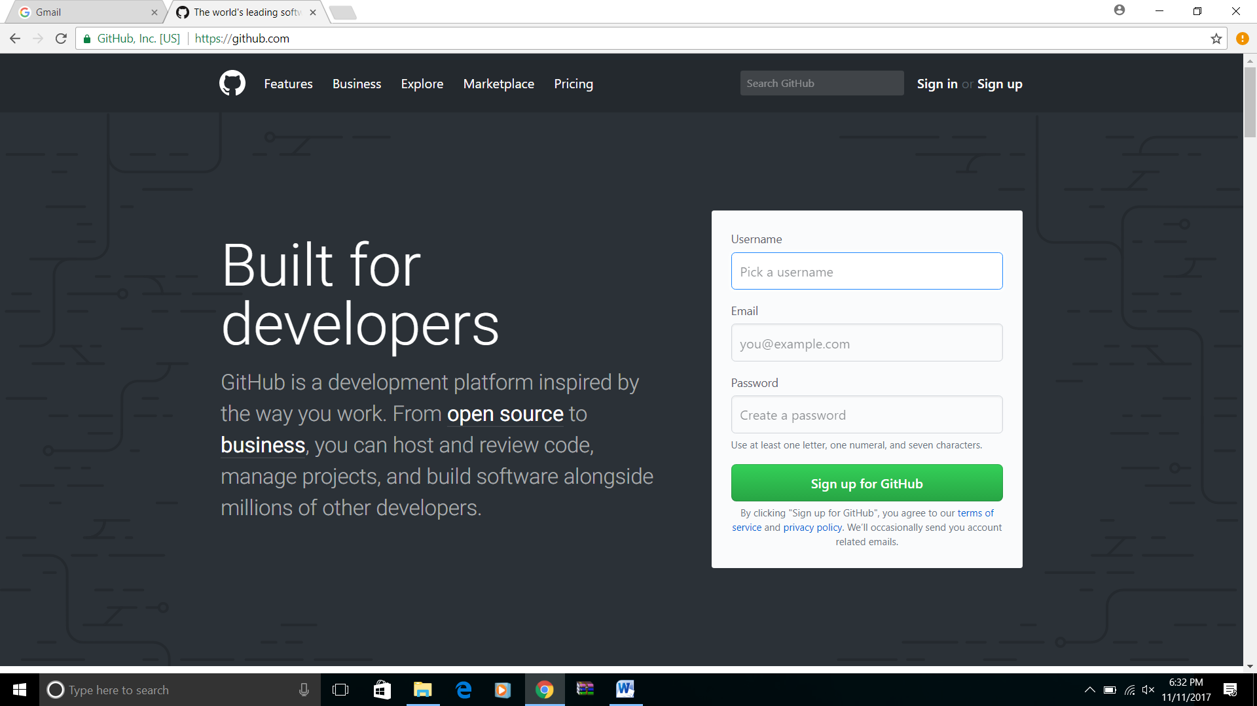

1. **Create an account**
2. **After creating account SignIn to github.com**
3. **Click on `New repository`**

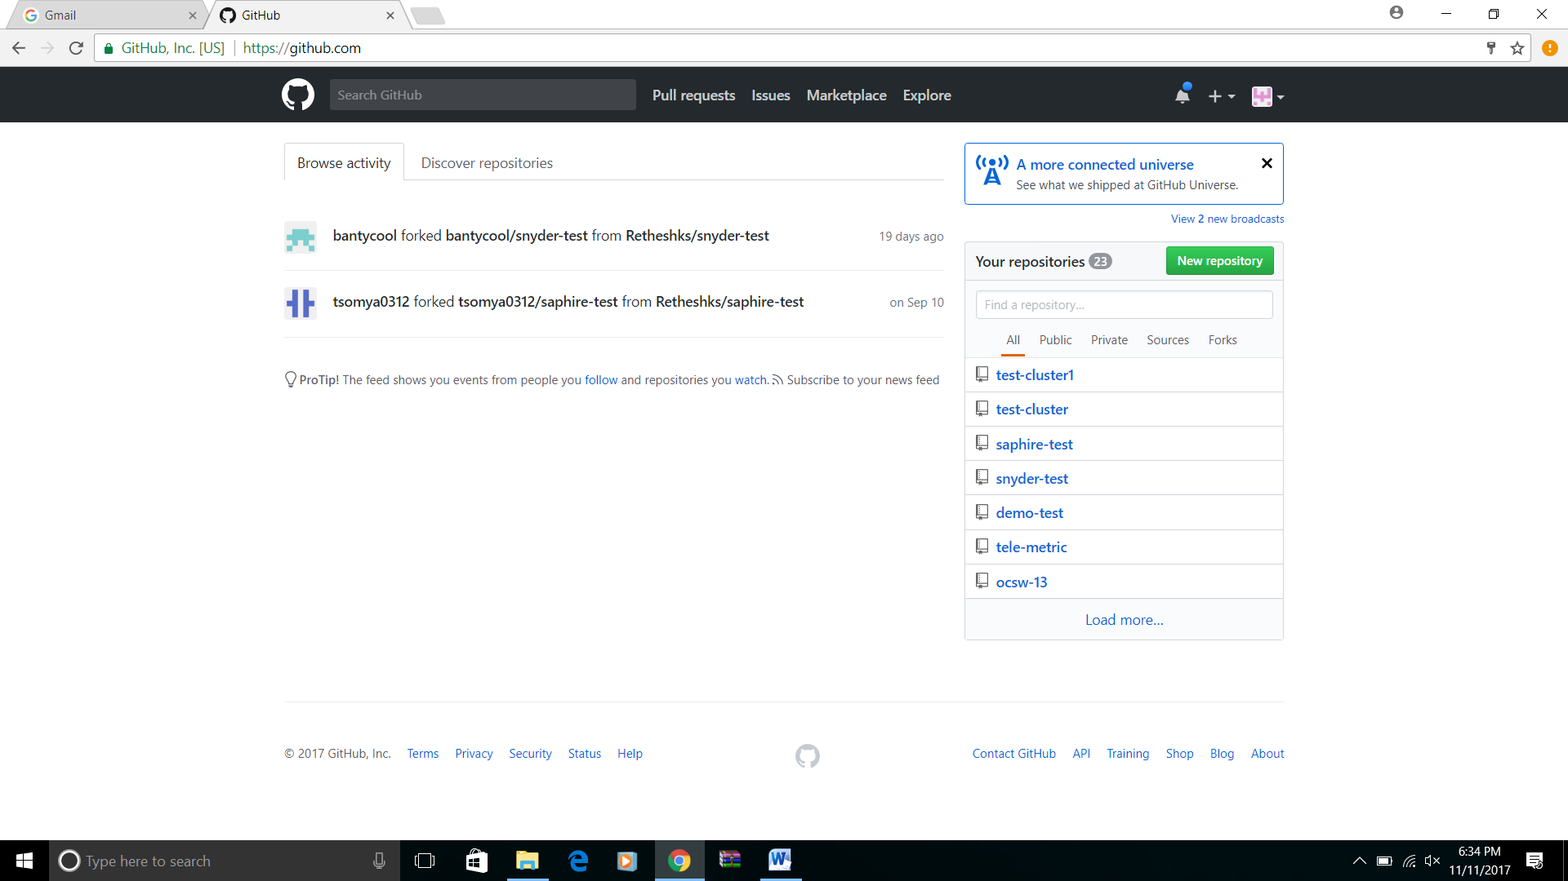

1. **Enter repository name, description**
2. **Choose public**
3. **Check initialize repository.**
4. **Click on create repository**

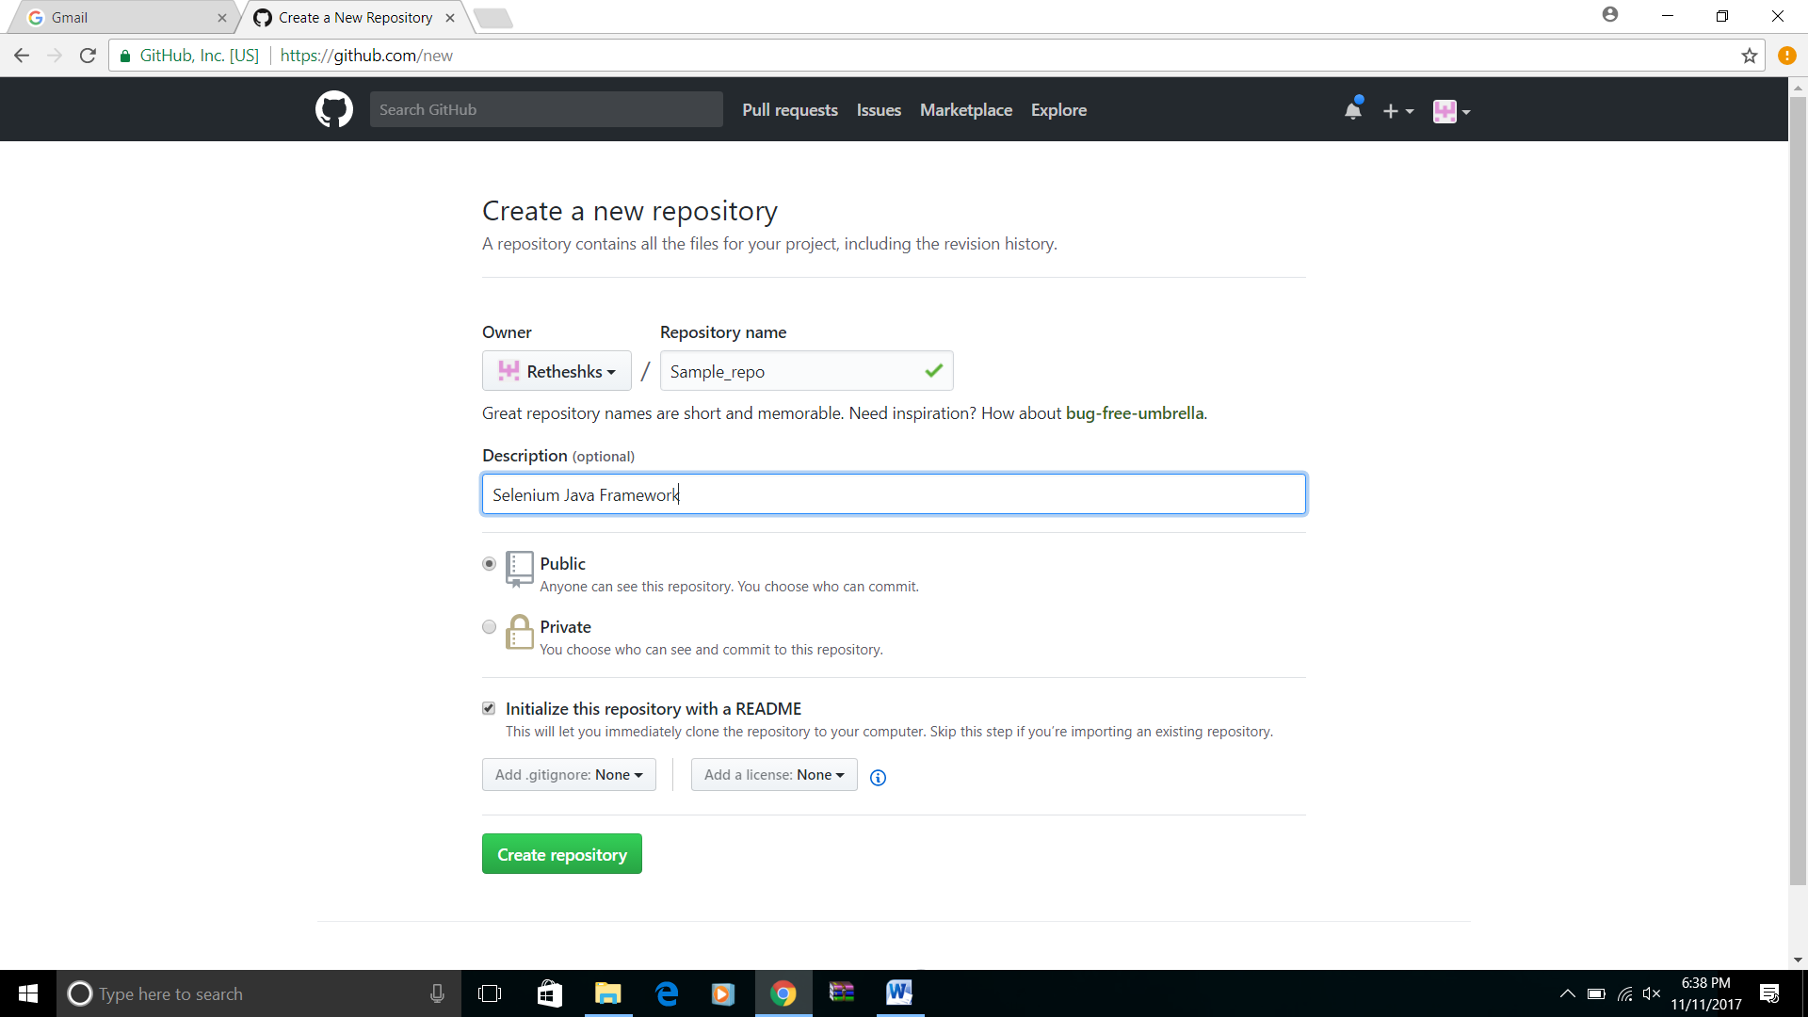

**Repository has created successfully**

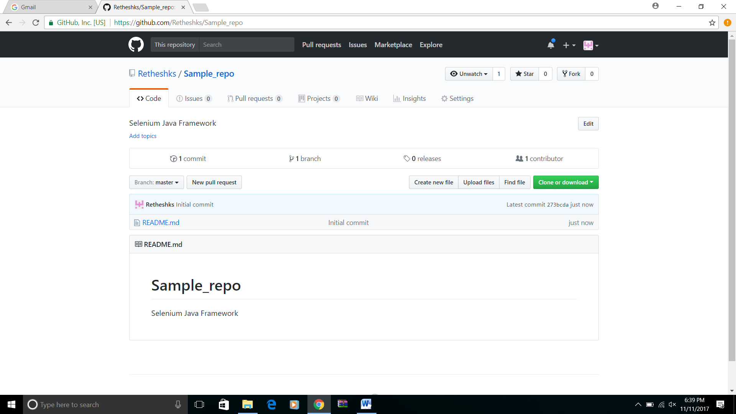

**Installation of Git-SCM**

1. **Got to below URL**

[**https://git-scm.com/**](https://git-scm.com/)

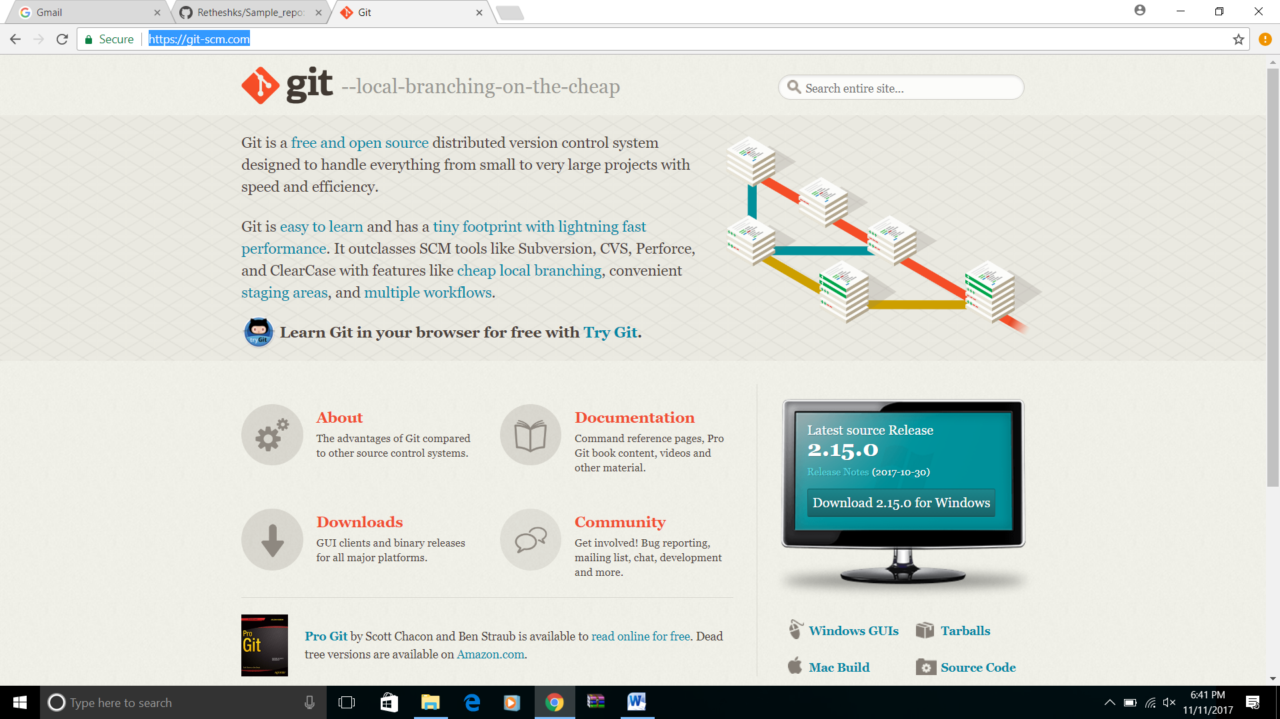

1. **Click on Download button.**
2. **File will get downloaded in .exe format**

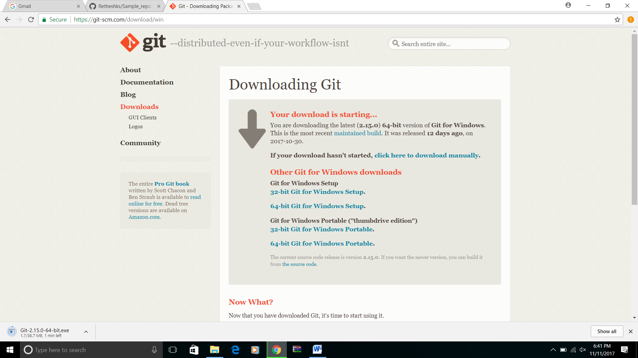

1. **Double click on downloaded .exe file and proceed with installation.**